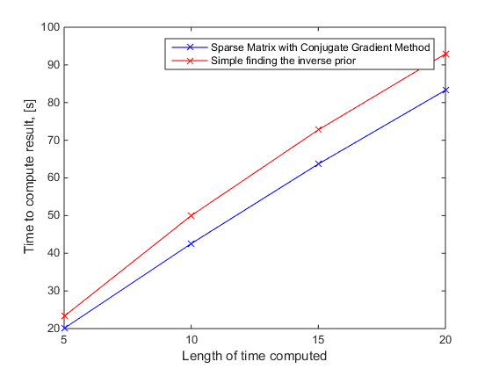

As you increase the length of time computed it is better to choose the sparse CGM. For dx=1e-3

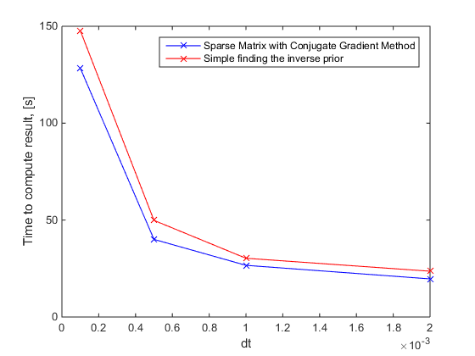

Decreasing the dt selected shows again that the better choice is the Sparse CGM. For dx=1e-3

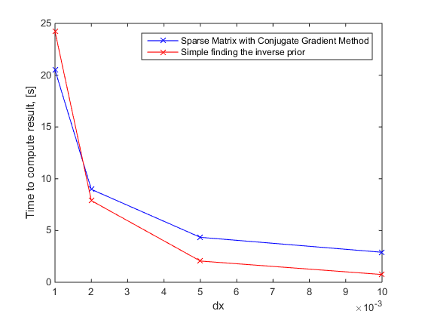

Decreasing the dx there is a change in which it goes from the sparse CGM to finding the inv prior as a better choice.

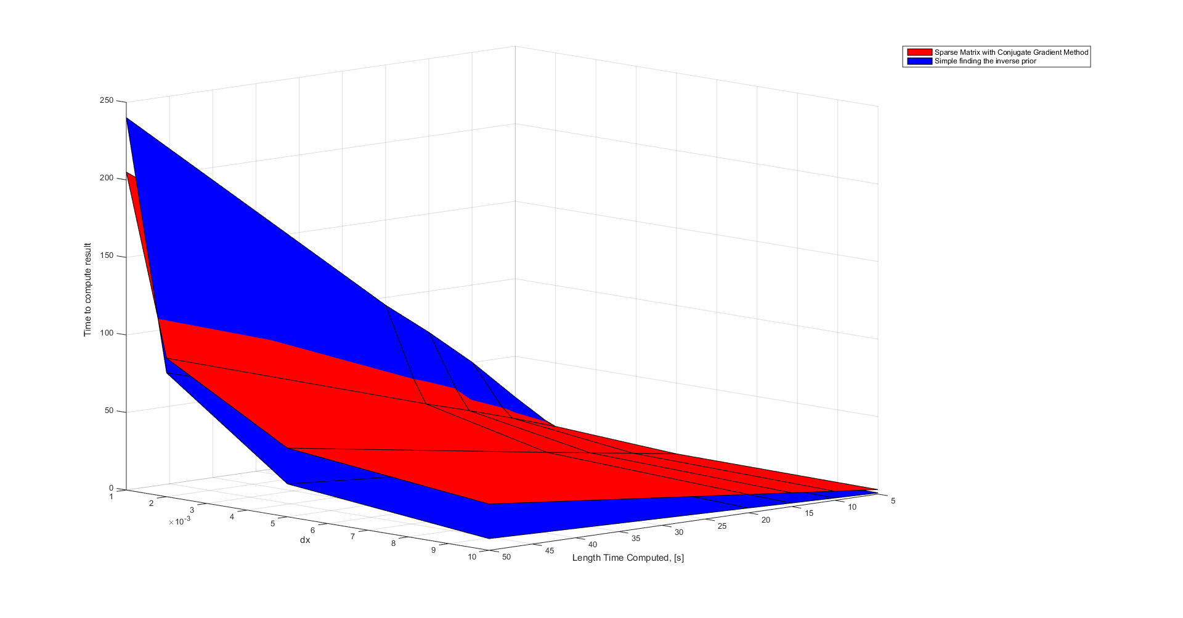

Given that {1e-3<dt< 2e-3} as long as the dx>2e-3 the best choice of method is the inverse of A prior to iterating method

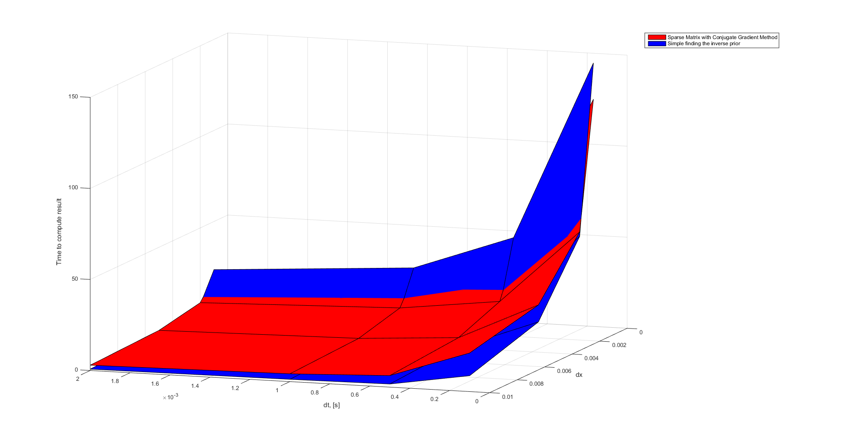

As long as dx >2e-3 the choice of method is the inverse of A prior to iterating through time.

**The choice of method will only become the sparse CGM when dx<2e-3**